Name: Krish Agarwal

Register Number: 21112016

Class: 5BSc DS

Full Stack

**Lab 1: Create a flask app to display calculation**

Q1) Create a simple html page which displays calculation, the text '2 add 3 = 5' comes from a python function in flask app.

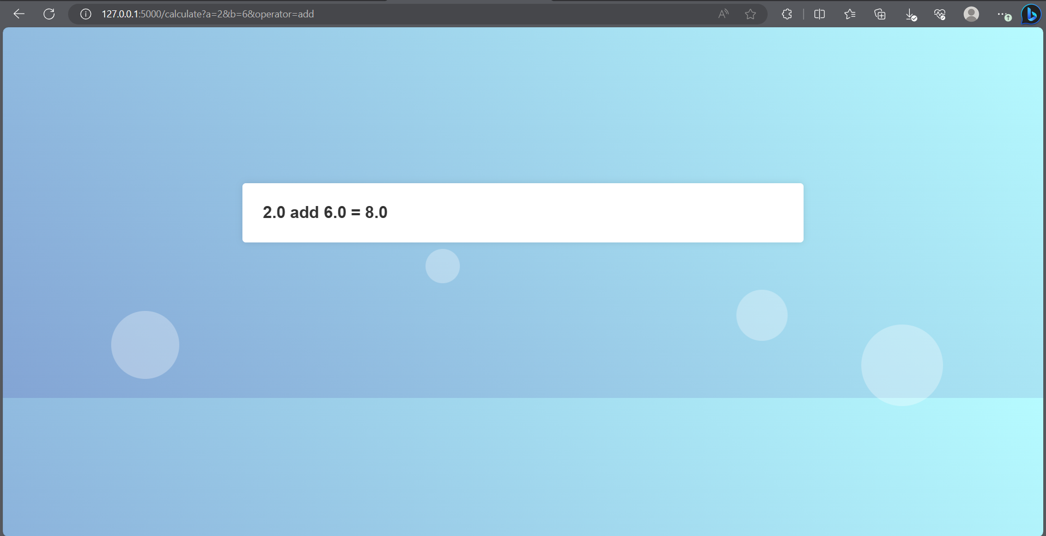

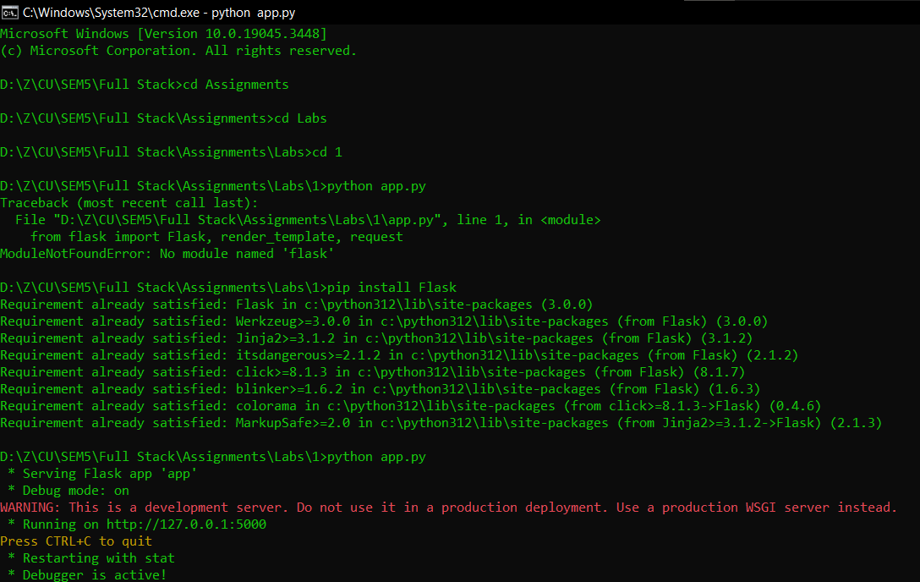

Q2) Create a python function calculate, pass 3 arguments inside the function a, b, operator using get request

If operator = add then a + b, If operator = subtract then a – b, If operator = multiply then a * b

If operator = divide then a / b; return the above text in html page: 2 add 3 = 5

Check by passing arguments in the url http://127.0.0.1:5000/calculate?a=2&b=3&operator=add

